* Software development lifecycle (SDLC):

The software development lifecycle (SDLC) is the cost-effective and time-efficient process that development teams use to design and build high-quality software. The goal of SDLC is to minimize project risks through forward planning so that software meets customer expectations during production and beyond.

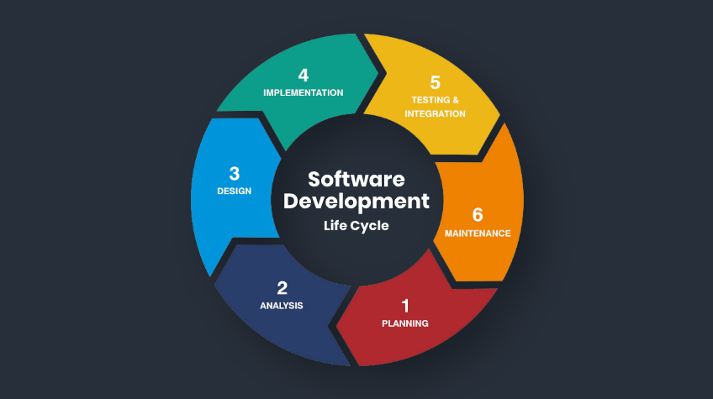

* Software Testing Life Cycle:

STLC stands for Software Testing Life Cycle. It's a process that involves a series of steps, or phases, to test software and ensure it meets quality standards

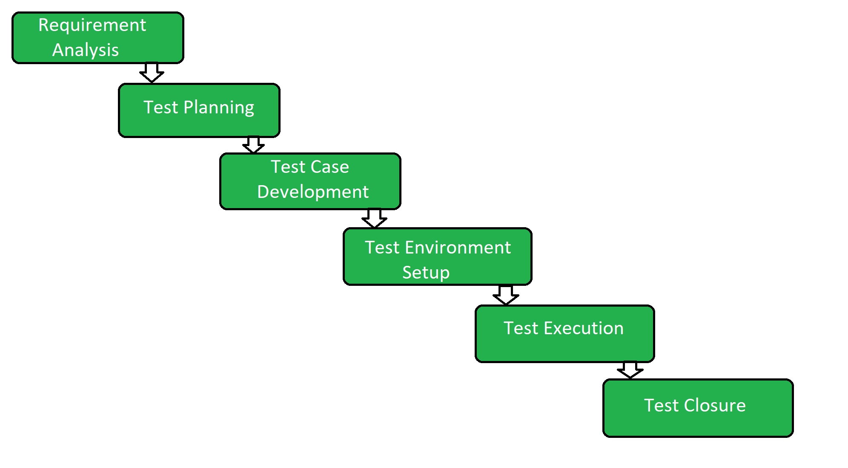

* **Agile methodology:**

Agile methodology is a project management framework that breaks projects into phases, called sprints. It's a responsive and iterative software development methodology that emphasizes continuous improvement and collaboration.

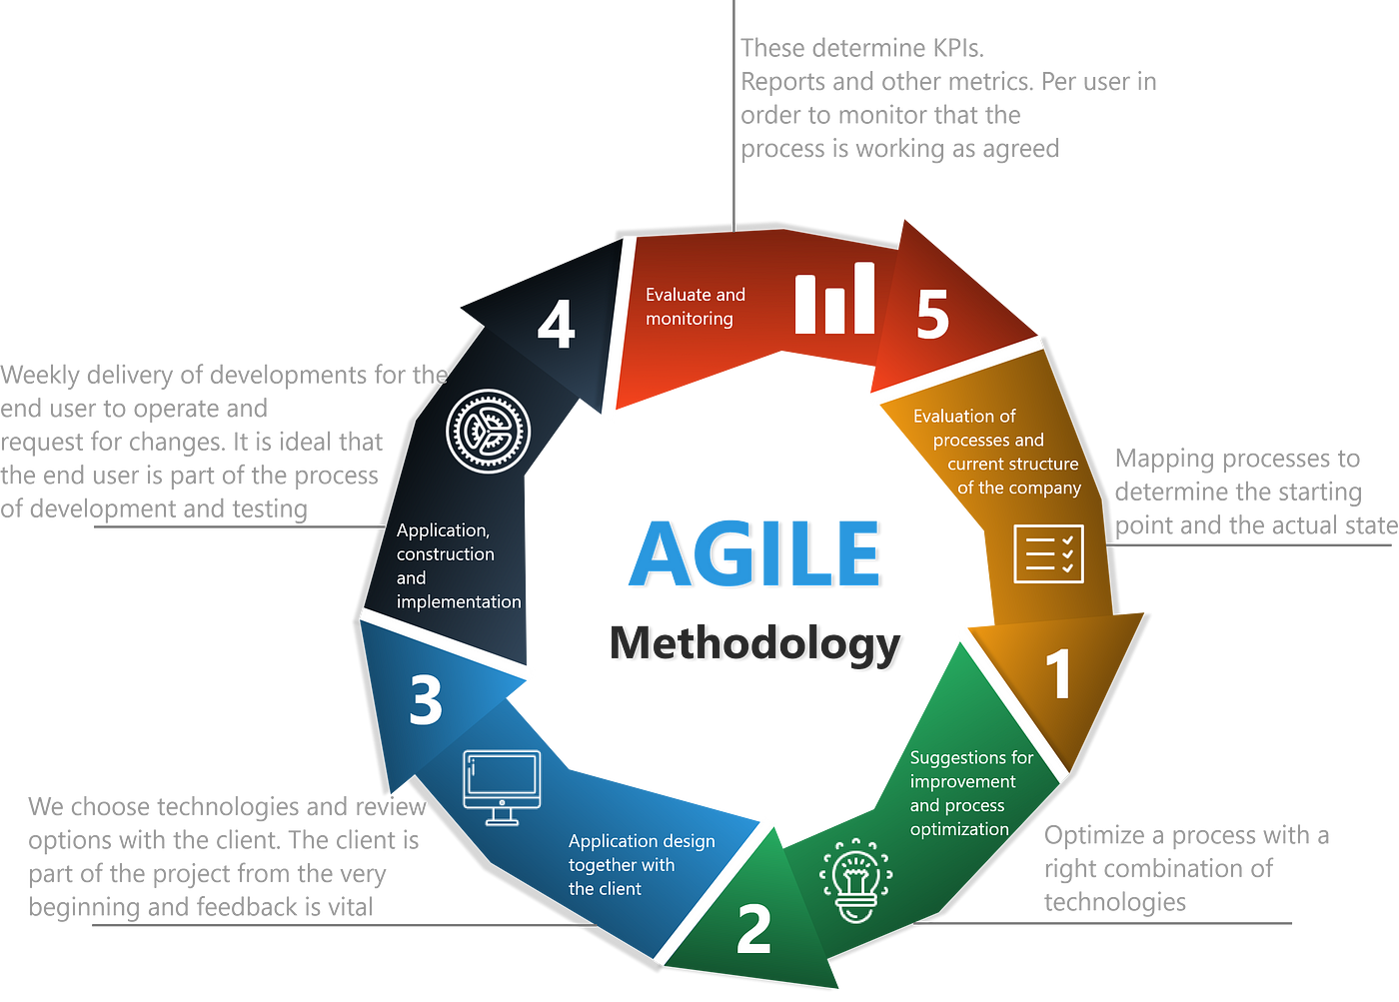

* **Waterfall Model:**

The Waterfall Model is a linear application development model that uses rigid phases: When one phase ends, the next begins. Steps occur in sequence, and, if unmodified, the model does not allow developers to go back to previous steps (hence “waterfall”: Once water falls down, it cannot go back up).

